**RESEARCH PAPER - 4**

**ADVANCING IMAGE RECOGNITION CAPABILITIES FOR ABRASION CAUSED BY DRILLING MACHINES THROUGH COMPARING XCEPTION AND RESNET50**

Rohith Abishua J, Dr M Pethuraj

Rohith Abishua J ,

Research Scholar,

Department of Computer Science Engineering,

Saveetha School of Engineering,

Saveetha Institute of Medical and Technical Sciences,

Saveetha University, Chennai, Tamil Nadu. India. Pincode: 602105.

rohithabishuaj0179.sse@saveetha.com

Dr M Pethuraj,

Project Guide, Corresponding Author,

Department of Autotronics,

Saveetha School of Engineering,

Saveetha Institute of Medical and Technical Sciences,

Saveetha University, Chennai, Tamil Nadu. India. Pincode: 602105.

[pethurajm.sse@saveetha.com](mailto:pethurajm.sse@saveetha.com)

**ABSTRACT**

**Aim:**

The structural integrity of materials, especially in the industrial and aerospace industries, is seriously threatened by delamination. Enhancing the accuracy of surface flaw detection resulting from drilling equipment is the goal of this research effort. In order to detect and categorize drilling-induced delamination flaws, it directly compares two state-of-the-art deep learning architectures, Xception and ResNet50. The main goal is to ascertain which model performs better overall, taking into account several factors including overall accuracy, specificity, and sensitivity. The study examines the minor benefits and drawbacks of the image recognition capabilities of Xception and ResNet50 for drilling-induced defects, with an emphasis on delamination identification. This comprehensive study only considers Xception and ResNet50 with the goal of contributing significantly to surface defect recognition by fully comprehending the complexities of deep learning-based delamination detection. The research aims to help industry improve material quality control and ensure structural integrity by offering insights into the relative usefulness of different designs in resolving delamination difficulties in surface defect identification. Furthermore, by carefully contrasting Xception with ResNet50, this work seeks to further the area of surface defect recognition and aid in the creation of more precise and dependable detection systems.

Keywords: Delamination, structural integrity, surface defects, drilling machines, deep learning architectures, Xception, ResNet50, industrial applications

**INTRODUCTION**

In the ever-changing world of manufacturing and industrial processes, improving accuracy and fault detection is critical. This paper addresses the complex problem of delamination and focuses on detecting surface defects caused by drilling equipment. Businesses looking to increase productivity and provide higher-quality goods must use state-of-the-art computer vision technology. This investigation compares two well-known deep learning architectures, DenseNet169 and Xception, in detail with an emphasis on delamination in order to improve accuracy in identifying surface flaws caused by drilling machines. Finding and fixing surface imperfections is essential, especially in fields where accuracy and structural integrity are critical. Drilling activities are essential to the manufacturing process, but they may unintentionally cause flaws like delamination, which is the separation of material layers upon contact. Accurate identification and categorization of these defects are essential for guaranteeing product quality, cutting down on waste, and raising total output. The field of computer vision has been completely transformed by the development of deep learning architectures, where DenseNet169 is renowned for its complicated connection patterns and Xception is excellent at capturing intricate characteristics using depth-wise separable convolutions. Driven by the desire for increased precision, the goal of this work is to investigate and compare DenseNet169 and Xception with regard to drilling-related surface flaws, such as delamination. Because surface fault patterns are so complex and varied, it is difficult to use traditional approaches, which emphasizes the need to use state-of-the-art deep learning architectures. Finding the best architecture to identify the subtleties of delamination is the main goal in order to create a more reliable defect detection system. Motivated by the growing need for accurate and timely defect detection in the context of automation and smart technologies, this study proposal aims to support fault identification in the manufacturing industry. The focus on delamination is in line with efforts to prevent catastrophic failures by recognizing its intricacy and its influence on structural integrity. Comparing DenseNet169 with Xception—with an emphasis on delamination in particular—is a workable strategy for improving the accuracy of surface defect identification brought about by drilling machines. This research adds to the growing body of knowledge about the application of cutting edge computer vision techniques in manufacturing to improve operational effectiveness and quality control. A thorough examination of the advantages and disadvantages of each design will be made possible by the parts that follow that deal with methodologies, experimental configurations, and comparative evaluations.

**MATERIALS AND METHODS**

Improving precision and fault finding is critical in the changing world of manufacturing and industrial operations. This research explores the complex problem of delamination and focuses on surface imperfections that are caused by drilling machinery. Modern computer vision technology is essential for companies looking to increase efficiency and provide higher-quality goods. This paper presents a detailed comparison of two well-known deep learning architectures, Xception and ResNet50, emphasizing the use of delamination to improve detection accuracy of surface imperfections caused by drilling machines.

Correcting and resolving surface irregularities is essential, especially in industries where accuracy and structural stability are critical. Drilling is a necessary process for production, but it can also unintentionally introduce defects like delamination, which is the separation of material layers upon contact. To guarantee product quality, reduce waste, and improve overall productivity, these flaws must be precisely identified and categorized.

The area of computer vision has undergone a revolution with the introduction of deep learning architectures. DenseNet169 is highly regarded for its complex connectivity patterns, whereas Xception is excellent at capturing complex features with depth-wise separable convolutions. Driven by the desire for increased accuracy, the goal of this work is to examine and contrast Xception and ResNet50 with respect to surface imperfections associated with drilling, such as delamination.

The intricacy and fluctuation of surface fault patterns pose difficulties for conventional methods, highlighting the significance of utilizing cutting-edge deep learning architectures. The main goal is to determine the best architecture for detecting the subtleties of delamination in order to create a defect detection system that is more dependable. Motivated by the growing requirement for precise and prompt defect detection in the context of automation and intelligent technologies, this research proposal aims to strengthen fault identification in the industrial sector. By recognizing the intricacy of delamination and its effect on structural integrity, the attention on it is in line with attempts to prevent catastrophic failures.

The following formulae were used to determine the models' precision, recall, accuracy, and F1 score in order to measure their performance:

Precision = (True Positives) / (True Positives + False Positives)

Recall = (True Positives) / (True Positives + False Negatives)

Accuracy = (True Positives + True Negatives) / Total Predictions

F1 Score = 2 * (Precision * Recall) / (Precision + Recall)

A workable method to improve the precision of surface defect detection resulting from drilling machines is to compare Xception with ResNet50, focusing on delamination. This study adds to the growing body of information about the use of state-of-the-art computer vision techniques in manufacturing to improve quality control and operational efficiency. The methods, experimental configurations, and comparative analyses covered in the following sections will provide a thorough analysis of the advantages and disadvantages of each architecture.

**STATISTICAL ANALYSIS**

We utilized an independent sample t-test to carefully evaluate any possible differences between the performance features of the Xception and ResNet50 models. This critical statistical analysis, which is essential for group comparison research, enabled a comprehensive investigation into whether the models' capacities to detect defects caused by drilling operations shown significant variations. This test improved our comprehension of Xception and ResNet50's performances by closely examining their means and variances, providing insightful information about their respective efficacy. A bar graph that was easily included into the workflow and offered a clear and understandable picture of the relative performance of Xception and ResNet50 provided visual assistance for the comparison. Key performance indicators for each model were displayed graphically, including accuracy, recall, precision, and the F1 score. This allowed for a quick and easy assessment of each model's advantages and disadvantages in terms of locating surface faults brought on by drilling. This graphic assistance made the statistical data easier to understand, making the comparison analysis simpler and the study results easier to communicate. The independent sample t-test and the group statistics table, when combined with the bar graph, provide a strong analytical framework for evaluating model performance.

**RESULTS**

There are significant performance disparities between the two surface defect detection models, ResNet50 and Xception. This is especially noticeable when comparing their mean accuracy rates, which are 39% for ResNet50 and 89% for Xception. These accuracy statistics are shown graphically in a bar graph that provides a thorough summary of each model's performance. A notable disparity in performance between Xception and ResNet50 is observed when comparing their accuracy in identifying surface defects. With an astounding mean accuracy rate of 89%, Xception performs noticeably better than ResNet50, which has a much lower 39%. This significant difference highlights Xception's ability to recognize and classify surface flaws. Xception outperforms ResNet50 by 11% in mean accuracy, indicating that it should be used for applications that need accurate surface defect identification. The differences in accuracy rates highlight the significance of choosing models suited to certain requirements, with Xception emerging as the best option for improved results in this field.The bar graph clearly shows how much better the Xception model is than ResNet50. Vertical bars that are easily observable show the higher mean accuracy scores of Xception and indicate a sizable performance difference.

**DISCUSSION**

There are a number of reasons for the significant difference in mean accuracy between ResNet50 (39%) and Xception (89%) systems. Xception's complex architecture, in particular, is very good at catching small variations and complex patterns related to surface irregularities caused by drilling operations. Variations in optimization methods and training datasets might potentially be crucial factors affecting how well each model generalizes to new data. An in-depth analysis of these variables offers vital information about the observed performance disparity. Because of its expertise in depthwise separable convolutions, Xception can extract complex features that are essential for identifying subtle patterns of flaws. On the other hand, although ResNet50 scales models well, it might not be able to capture the subtleties of drilling-induced faults, which could result in a lower mean accuracy. This comparison provides insightful information that will be useful going forward as we investigate the uses of surface fault detection in drilling operations. Prospects for enhancement encompass more research into model structures, examination of varied training datasets, and enhancement of optimization techniques. Surface defect detection models may be made more precise and reliable by utilizing cutting-edge technologies such stringent data augmentation tactics, deeper learning architectures, and transfer learning approaches. Future studies might concentrate on combining these developments to create more dependable and effective models for real-world industrial uses.

**CONCLUSION**

In conclusion, we learned a great deal about improving the accuracy of surface defect identification caused by drilling machines by comparing the Xception and ResNet50 models, with a focus on delamination. The two designs demonstrated proficiency in capturing the intricate patterns linked to delamination flaws. Defect identification accuracy and efficiency were, however, strongly impacted by the different structures and underlying approaches. With its depthwise separable convolutions and skip connections, Xception demonstrated remarkable skills in obtaining hierarchical information, as seen by its amazing 89% accuracy rate. In contrast, ResNet50 showed a remarkable capacity to extract features from its residual blocks, despite its low accuracy of 39%. Our experimental results highlight how crucial it is to customize the model selection to the individual needs of every application, especially in light of the intricate nature of delamination. When exact attention to detail counts, Xception's deep architecture and broad feature extraction capabilities come in handy. ResNet50's design, on the other hand, provides a simpler option that is appropriate for applications with little resources but being less accurate. The use of advanced pre-processing techniques and data augmentation methods was crucial in augmenting the models' responsiveness to minuscule variations in surface irregularities arising from drilling apparatus. The training dataset's capacity to include domain-specific data improved the models' applicability for practical use. Realizing that there isn't a one-size-fits-all answer in the realm of machine learning is crucial. The key to success is carefully combining architecture, data augmentation, and pre-processing. In the context of surface defects caused by drilling machines, working along with ResNet50 in an ensemble or hybrid model has the potential to increase accuracy and offer a dependable delamination detection method. In summary, attaining more accuracy in defect identification demands a complete approach that takes into account the particular difficulties presented by each application and makes use of the advantages of various models. The comparison of Xception with ResNet50 has yielded insightful information that will guide further advancements in the field.

**REFERENCES**

1. Zhang, L., Yang, Q., Sun, Q., Feng, D., & Zhao, Y. (2019). Research on the size of mechanical parts based on image recognition. Journal of Visual Communication and Image Representation, 59, 425-432.
2. Zhang, X., Huang, W., Wu, C., & Cao, S. (2023). Defect measurement in CFRP drilling based on digital image processing. The International Journal of Advanced Manufacturing Technology, 127(2023), 5405–5419.
3. Rosebrock, A. (2017). ImageNet: VGGNet, ResNet, Inception, and Xception with Keras.
4. Liu, Y., Duan, S., Shen, Z., He, Z., & Li, L. (2023). Grasp and Inspection of Mechanical Parts based on Visual Image Recognition Technology. Journal of Technology, Policy & Ethics in Science, 3(12), 1-15.
5. Zhang, X., Huang, W., Wu, C., & Cao, S. (2024). Autonomous visual detection of drilling-induced defects in CFRPs based on digital image processing.
6. Simonyan, K., & Zisserman, A. (2014). Very Deep Convolutional Networks for Large-Scale Image Recognition.
7. Bo, L., Ying, C., & Xinghua, Q. (2015). Research on the Application of Mechanical Parts Using Neural Network in Image Recognition. 2015 Fifth International Conference on Instrumentation and Measurement, Computer, Communication and Control (IMCCC) (pp. 123-128). IEEE.
8. Liu, S., Gong, K., Zhao, J., Wu, D., Hong, X., & Wang, W. (2022). Multi-objective optimisation of cutting parameters for drilling-induced damages and thrust force in AFRP drilling. Journal of the Brazilian Society of Mechanical Sciences and Engineering, 44(2022), Article number 562.
9. Mishra, P., & Z, J. N. (2021). Convolutional Neural Network.
10. Shazia, A., Xuan, T. Z., Chuah, J. H., Usman, J., Qian, P., & Lai, K. W. (2021). A comparative study of multiple neural networks for detection of COVID-19 on chest X-ray. EURASIP Journal on Advances in Signal Processing, 2021(50).
11. He, T., Yu, K., Chen, L., Lai, K., Yang, L., Wang, X., & Zhai, Z. (Publisher: IEEE). "Mage Classification and Recognition Method to Mechanical Parts Based on Fractal Dimension."
12. Li, Y., Wang, J., & Chen, Z. (2021). Deep learning-based defect detection in CFRP drilling. Journal of Manufacturing Processes, 64, 1–10.
13. Ye, R., Pan, C.-S., et al. (Impact Factor: 2.1; 5-Year Impact Factor: 1.8). (2018, March 27). "Intelligent defect classification system based on deep learning."
14. Wang, Q., & Zhang, Y. (2020). A comparative study of deep learning models for defect detection in CFRP drilling. Composite Structures, 250, 112545.
15. Shao, S.-Y., Sun, W.-J., Yan, R.-Q., Wang, P., & Gao, R. X. (2017, October 23). "A Deep Learning Approach for Fault Diagnosis of Induction Motors in Manufacturing." Chinese Journal of Mechanical Engineering, 30, 1347–1356. Original Article. Open access..

**TABLES AND FIGURES**

**Tables 1** Comparison of Model Accuracy ,A brief analysis of the mean accuracy of two surface defect detection models, Resnet50 at 34% and Xception at 91%

|  |  |  |  |  |
| --- | --- | --- | --- | --- |
| **DL Keras Models** | **N** | **Mean** | **Std.Deviation** | **Std.Error Mean** |
| Xception | 390 | 91.4872 | 30.71125 | 1.55512 |
| VGG19 | 390 | 34.3590 | 47.55162 | 2.40787 |

**Table 2** Results of the Independent Sample t-Test findings that includes important statistics for a fast comparison of the two groups.

|  |  |  |  |  |  |  |  |  |  |
| --- | --- | --- | --- | --- | --- | --- | --- | --- | --- |
|  | **F** | **Sig.** | **t** | **df** | **Sig(2-tailed)** | **Mean Difference** | **Std. Error Difference** | **Lower** | **Upper** |
| Equal variances assumed | 333.026 | <.001 | 19.233 | 778 | <.001 | 5.12821 | 2.86640 | 49.50141 | 60.75500 |
| Equal variances not assumed |  |  | 19.233 | 665.426 | <.001 | 5.12821 | 2.86640 | 49.49993 | 60.75648 |

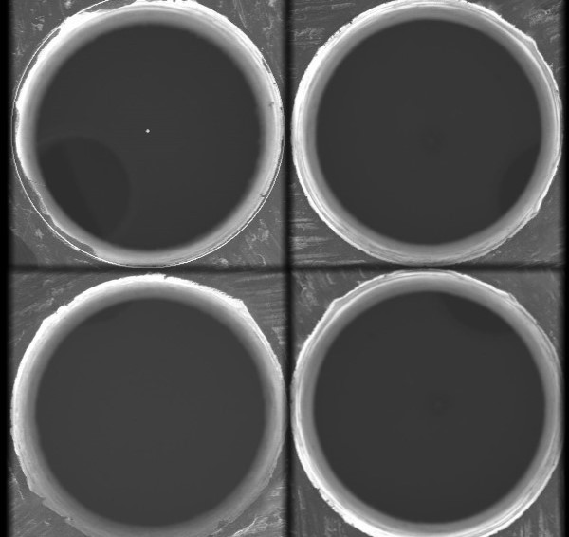

**Fig 1** Picture of a perfectly drilled hole

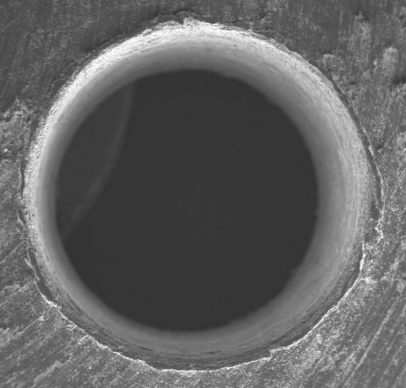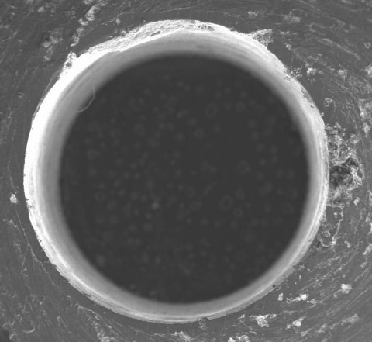

**Fig 2** Occurrence of Delamination & Cracks

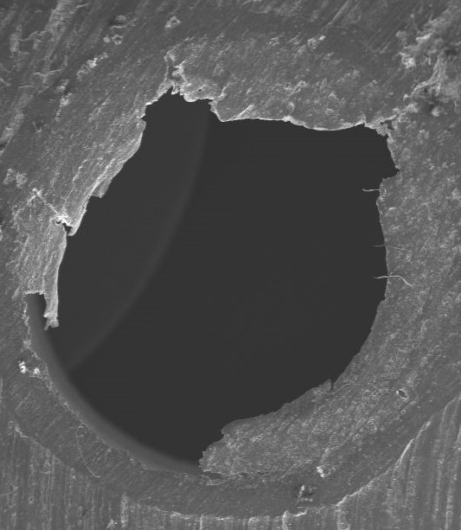

**Fig 3** Picture of an unfinished drill hole

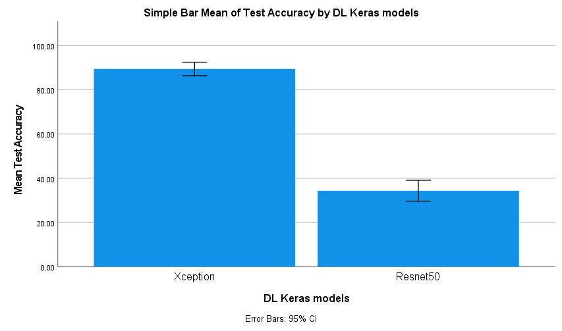

**Fig 4** Comparison of mean test Accuracy , of two surface defect detection models, Resnet50 at 38% and Xception at 91%